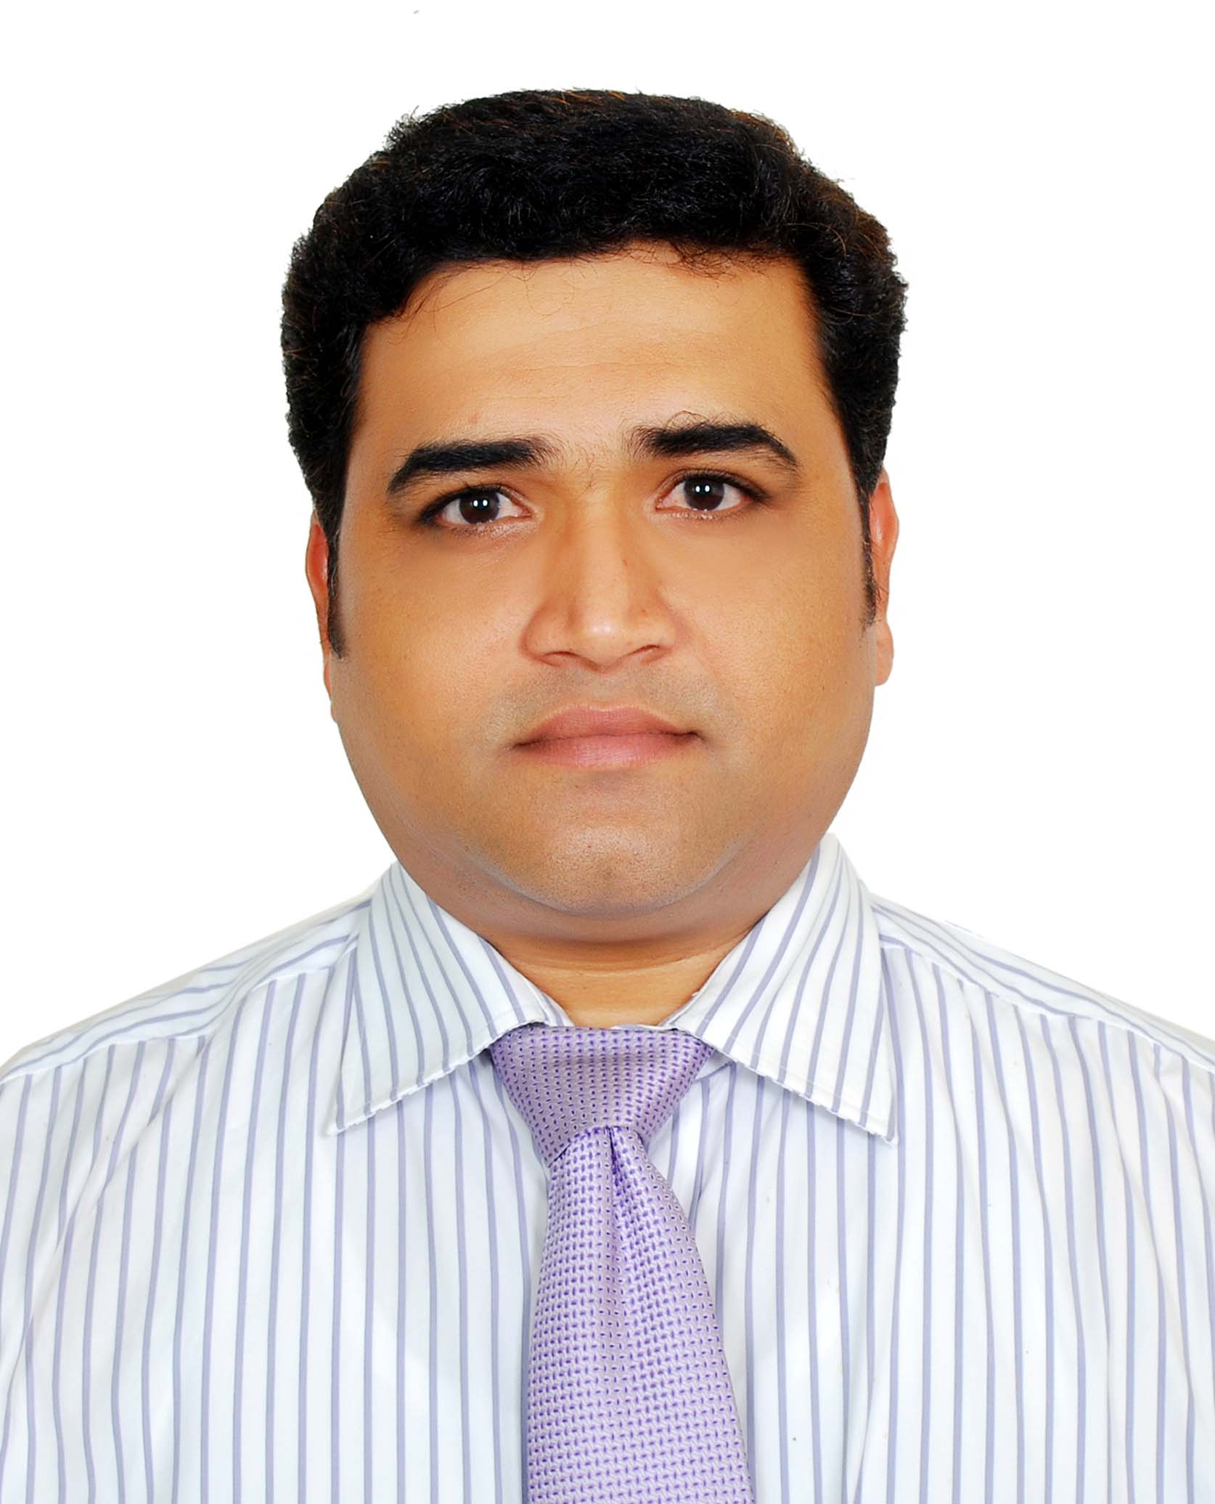

Sales & Business Development - Customer Service Professional with UAE Exp.

Mohammed Shahjahan - B.Com., DBA
Door No. 6.3.300, Ram Nagar, Anantapur – 515001 – Andhra Pradesh – INDIA
Contact: +91 9908075585 – 91 8374285113
E-mail: mdsjobs@hotmail.com, mdshahjahan33@gmail.com
Skype id : shahjahan_33

Dear Manager - HR
In today's customer service oriented society, timely, friendly, proactive service is sought to enhance future business growth. Customer loyalty is always impacted when you employ the right service professional to represent you when assisting your valued customers.
My long term experience in the Sales & Business Development - Customer Service industry in India and UAE has taught me how to meet and exceed each customer's expectations with service that sells. I have assisted all types of customers in all types of settings. I realize that acquiring and maintaining loyal repeat business as well as spreading the word of your business through these loyal patrons is of the utmost importance in every company. Positioning a company for better exposure and greater marketability is a task that I have performed with success many times. As I am quick learner I can handle the given job and responsibility professionally, and I am ready to use my experience to achieve the company’s goals
It would be a pleasure to interview with you and I look forward to hearing from you soon.
Very Sincerely,
Shahjahan

B.Com + DBA, Sales & Business Dev - Customer Service Professional UAE Exp.

Rich experience in delivering optimal results & business value in high-growth environments in the areas of Sales & Marketing - Customer Relationship Management / FMCG/Online Selling /Internet - Ecommerce/ Telemarketing / Customer Coordinating
PROFILE
- Rich exposure in direct marketing, telemarketing and following up of the customers till the product delivery
- Proven expertise in Business Development - customer service
- Strong background in Office Management, Operations, Customer Services, Grievance handling etc. Thrive in a deadline intensive environment
- Multi-task, perform under pressure and meet deadlines. Goal-oriented, systematic planner with a big-picture perspective
- Excellent man-management, time management, leadership skills. Computer Proficient

Key Competencies

 Sales & Business Development  Customer Service  Back End Operations  Office Management  Market Development  Target Achievement  Client Relationship Management  Retail Banking  Analytical/Negotiation Skills

Professional Highlights – In Short

Print City Graphics - Anantapur - India
Sr.Business Development Officer
September, 2013 to Till Date
• Role : Business Development – Print & Publishing
Target Job Category

- FMCG
- Sales & Marketing
- Channel Sales
- Admin
- Retail Banking
- Logistics
- Retailing
- Customer Service & Support
- Client Management
- Marketing Coordinator
Etc.,

Metro Link – Journal - Chennai - India
Sr.Business Development & Customer Service Officer
November 2008 to August 2013 ( 3.5 yrs )
• Role : Business Development - Space Selling

ABU DHABI COMMERCIAL BANK - DUBAI - UAE
Sr. Sales & Customer Service Officer – Retail Banking Products
January, 2007 to August, 2008 - ( 1.5 years )
- Role : Selling Banking Products – Business Dev - Customer Service

Sharp Prints Pvt Ltd - Chennai - India
Sr. Marketing / Customer Service Executive / Space Selling etc.,
April, 2002 to April, 2006 - ( 4 + years )
- Role : Business Development – Space Selling

Aptech Computer Education – Trichirapalli - India
Marketing Executive – ( Computer Education Courses )
June, 1998 to February, 2002 ( 3.8 yrs )

Professional Highlights – In Detail – ( last 3 jobs )
Print City Graphics - ( Print & Publishing ) – Anantapur – India

Position : Sr.Business Development Officer
Period : September, 2013 to Tilldate

- Geared the activities to develop the business by getting new orders for print and publishing
- Fully accountable for maintaining customer database, manage telephone inquiries and complaints
- Contributed significantly in establishing and implementing short and long-range departmental goals
- Growing existing relationships and exceeding revenue goals
- Proven track record of generating new business
- Provided customers with information about products and services
- Follow up of existing Customers and getting in new customers

Metro Link - Chennai – India ( Print & Publishing )

Position : Sr.Business Development & Customer Service Officer
Period : November, 2008 to August, 2013

- Develop the business by selling Space in News Journal - getting fresh orders for printing etc
- Acquired budgeted sales goals and retained existing customers.
- Organized meetings with Potential Clients for fresh business and aided collections.
- Managed follow up and proactive sales calls.
- Recognized prospects and delivered sales plans.
- Proven track record of generating new business
- Growing existing relationships and exceeding revenue goals
- Superior communication, organization and presentation skills
- Excellent English oral and written communication skills
- Maintaining excellent eye for detail and to keep accurate records
- Dealt with telephone calls, correspondence and routine enquiries.
- Vast experience in delivering exceptional customer service
- Proficient with PC hardware and software
- Established and maintained effective relationships with customers
- Worked directly with people in a customer service capacity
- Handled and Solved various customer objections
- Provided customers with information about products and services
- Established and maintained relationships with clients by providing top quality service.
- Investigated and resolved customer problems.
- Interacted with other departments to ensure quality service in placing orders and organizing promotional events.

Key Achievements
- Achieved revenue and customer retention goals while increasing client profitability through relationship building, outstanding service delivery, cross selling and referral development.

ABU DHABI COMMERCIAL BANK – ADCB – DUBAI - UAE

Position : Sr.Sales & Customer Service Officer – Retail Banking Products
Period : Jan - 2007 to Aug - 2008 - ( 1.5 years )

- Hardcore selling of financial products like Credit Cards – Loans etc
- Actively involved in direct marketing, telemarketing and following up of the customers till the product delivery
- Initiated the turnaround efforts as active coordinator between the bank and the customer
- Instrumental in handling the queries of the customers of different nationalities regarding the product and its features
- Listing of companies with ADCB for credit facilities and crafting the payroll for Big and Small companies
- Maintaining appropriate documentation while ensuring precision, and accuracy
- Managed follow up and proactive sales calls - Proven track record of generating new business

Key Achievements
- Gained invaluable experience in Sales & Business Development – Customer Service
- Interacted with customers of various Nationalities & got good exposure in Banking products and policies

Note : I left the job in Dubai at the time of recession in 2008

Educational Credentials

Bachelor of Commerce
University of Madras – Chennai - India

Diploma in Business Administration
National Institute of Industrial Research and Development (NIIRD) – Chennai - India

Diploma in Information & Systems Management
Aptech Computers Ltd, Trichy – Tamil Nadu - India

Diploma in Web Design
Artech Institute, Chennai - India

I.T. Skills
Windows 7 & Vista, Adobe Photoshop, Illustrator, CorelDraw, MS Office, Photobucket,

Personal Details

Passport No : K 4160267 ( valid upto 2022 )
Fathers Name : Abdul Muneer ( Rtd. Sr. Engineer – BHEL – Trichy – Tamil Nadu – India )
Sex : Male
Nationality : Indian ( Andhra Pradesh – State )
Marital Status : Married
Languages Known : English, Hindi, Tamil, Telugu and Malayalam
Address : Door No. 6.3.300, Ram Nagar, Anantapur – 515001 – Andhra Pradesh – INDIA
Mobile : +91 9908075585 – 91 8374285113
E-mail : mdsjobs@hotmail.com, mdshahjahan33@gmail.com

